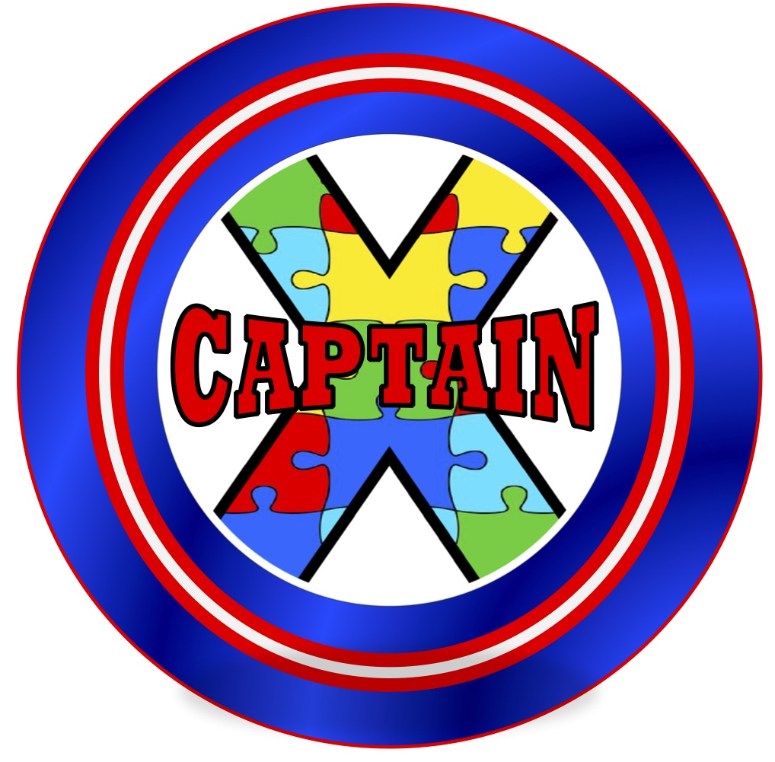

CAPTAIN X Newsletter

Volume 10

May 2021

Now that the Covid-19 cases in the State of California continue to decline, many families may feel more comfortable enjoying the great outdoors and other summer activities that were not available last year. In this issue, we will focus on the recent additions to the list of Evidence-based Practices, specifically: **Sensory Integration** and **Music Mediated Intervention**. Both interventions can provide families with activities they can do in the comforts & safety of their homes.

Transitioning back to school after many months at home may create some anxiety for students and families. With a little planning and preparation, families and educators can increase the chances of a smooth transition.

Whether your student opted to continue with distance learning for the remainder of the school year or has returned to in-person classes, resources on evidence-based practices always come in handy!

Fortunately, CAPTAIN created two padlets full of resources designed to ease the transition. Families and educators can access guidance documents, student supports, and preparation strategies.

Check out these excellent resources on page 4.

**What is Sensory Integration (SI)?**

**Sensory Integration** is a theory developed by A. Jean Ayres, an occupational therapist with advanced training in neuroscience and educational psychology. Ayres defines sensory integration as "the neurological process that organizes sensation from one's own body and from the environment and makes it possible to use the body effectively within the environment". The theory is used to explain the relationship between the brain and behavior and explains why individuals respond in a certain way to sensory input and how it affects behavior. The five main senses are:

* Touch - tactile
* Sound - auditory
* Sight - visual
* Taste - gustatory
* Smell - olfactory

In addition, there are two other powerful senses:

a) Vestibular (movement and balance sense)-provides information about where the head and body are in space and in relation to the earth's surface.

b) Proprioception (joint/muscle sense)-provides information about where body parts are and what they are doing.

Evidence-based practice in focus: Sensory Integration (SI)

Please consult an Occupational Therapist regarding appropriate Sensory integration activities for your student/child.

A sensory space—An area to be active and physical or to be calm with quiet time

Activities to provide touch and texture—Play-Doh®, beads, stress ball

Alter lighting—natural or soft lighting that may be difficult for visually impaired individuals

Improve classroom seating—adjust chairs for optimum fit, provide textures (therapy ball) or a vibrating cushion for sensory feedback

Physical activities/sports in between classes

**Sensory Activities in the Home**

**Adaptations within the School Setting**

*CAPTAIN X Newsletter • Volume 10 (May 2021)*

Evidence-based practice in focus: Music Mediated Intervention (MMI)

**What is Music Mediated Intervention (MMI)**

Intervention that incorporates songs, melodic intonation, and/or rhythm to support learning or performance of skills/behaviors. It includes music therapy, as well as other interventions that incorporate music to address target skills.

*CAPTAIN X Newsletter • Volume 10 (May 2021)*

**5 Ways to Incorporate Music to the Activities of Individuals with Autism:**

1. If your child can’t fill in the last word to a song phrase, give them a movement to imitate instead.  This will help make your child feel successful even if they are still learning to talk.
2. Set a [Social Story™](http://www.thegraycenter.org/social-stories) to a familiar children’s tune or chant it to a rhythmic beat. Melody and rhythm make the script easier to remember and can help add variety when reading the same story multiple times.
3. Use novelty to increase motivation. For example, sing in a silly voice, create sound effects, or bring out the bubbles!  This can be especially effective if your child appears fatigued or more difficult to engage during instruction.
4. Choose relevant musical rewards!  For example, if you are working on colors, allow your child to play a rainbow xylophone after identifying color flashcards, or sing “Old MacDonald” as a reward after your child completes an animal puzzle. Another way to approach musical rewards is to incorporate them within the task itself.  Using this method, the child may actually identify colors on the xylophone itself rather than receiving the xylophone as a reward after identifying colors on flashcards. Embedding motivators into instruction is a common approach during [Pivotal Response Treatment®](http://www.koegelautism.com/about-pivotal-response-training.html), which is frequently used by ABA providers.
5. Help your child tap their hand to a beat with each syllable when working on speech imitation.

Source: Tuned-In to Learning

Resources:

*CAPTAIN X Newsletter • Volume 10 (May 2021)*

English padlet: <https://padlet.com/SELPACAPTAIN/a8koaq55ly7m72rs>

Spanish padlet: <https://padlet.com/SELPACAPTAIN/fi0rpf81ldrdhxiv>

|  |
| --- |
| **Looking for safe summer activities?**  Finding activities outside of the home is a challenge due to the pandemic. Check out the Autism Society of the Inland Empire’s virtual activities here:  <https://ieautism.org/socialrec_services/>  Check out a list of 10 fun summer activities here:  <https://autismservices.chancelight.com/blog/summer-activities-autism/> |

**Other Online Resources:**

**California Autism Professional Training and Information Network:** Learn more about how the use of Evidence-Based Practices are developed and supported across the state of California. <http://www.captain.ca.gov/>

**Autism Focused Intervention Resources and Modules:** AFIRM Modules are designed to help you learn the step-by-step process of planning for, using, and monitoring an EBP with learners with ASD from birth to 22 years of age. Supplemental materials and handouts are available for download. <http://afirm.fpg.unc.edu/afirm-modules>

**Autism Internet Modules:** Designed for those who support, instruct, work with, or live with someone with autism, the Autism Internet Modules (AIM) guide users through case studies, instructional videos, pre-post-assessments, discussion questions, activities and more. <https://autisminternetmodules.org/>

**American Music Therapy Association:** The AMTA focuses on the progressive development of the therapeutic use of music in rehabilitation, special education, and community settings. The following link provides resources related to using Music Therapy with individuals with autism. <https://www.musictherapy.org/research/music_therapy_and_autism_spectrum_disorder/>

CAPTAIN X Newsletter • Volume 2 *(December 2016)*